

Leadership 2022: Future, Engage & Deliver

3rd / 4th November 2022

The Queens Hotel, Meyrick Rd, Boscombe, Bournemouth BH1 3DL
Thursday 3rd November |  | Friday 4th November
0900 | Registration / Refreshments | 0900 | Registration / Refreshments
0930 | Welcome from our Chair & Sponsor | 0930 | Welcome & Introductions
0940 | Kate Browning  SEND Leadership  ‘Using our best endeavours approach’ | 0940 | Transform Applied Project:  Steve Radcliffe & Fiona Moore
1030 | Morning Break | 1045 | Morning Break
1100 | Heba Al-Jayoosi  SEND Classroom practice  ‘Using a case study to demonstrate honest and realistic strategies to support pupils with SEND’ | 1115 | Continued
1230 | Hot Buffet Lunch | 1215 | Hot Buffet Lunch
1330 | Chris Caws  Well Schools Project | 1315 | Continued
1430 | Afternoon Break | 1430 | Afternoon Break
1500 | WALE – How we can support YOU? | 1500 | Continued
1600 | Close | 1600 | Close
FOLLOW US ON TWITTER @WALE_Leaders
TWEET US USING #LEADHAPPY

WALE AUTUMN CONFERENCE 2022 SPEAKERS – DAY 1

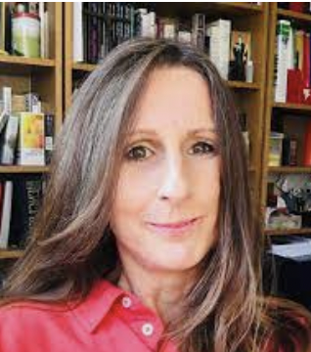
KATE BROWNING
Kate is an independent SEND Consultant who focuses on school improvement for SEND. She has been (I’m giving you the short version) a SENCo, SEN advisory teacher, local authority school improvement officer for SEND and interim Education Development Officer for NASEN. She teaches the NASENCo course for the university of Northampton and lectuers for the university of Warwick on their PGCE programe. Kate also facilitates the SENCo network across Leicstershire, Warwickshire and Derbyshire, supports Governors and is also a Chair of Governors

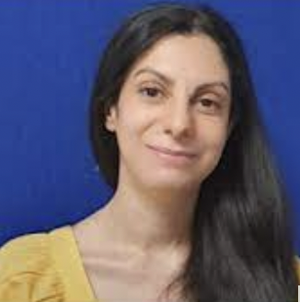
HEBA AL-JAYOOSI
Heba is an Assistant Headteacher and Inclusion Leader at Mayflower Primary School in East London, and has been seconded as a deputy regional lead at Whole School SEND, a consortium hosted by the National Association for Special Educational Needs. She will be sharing her knowledge on how to build inclusive practice in schools.

WALE AUTUMN CONFERENCE 2022 SPEAKERS – DAY 2

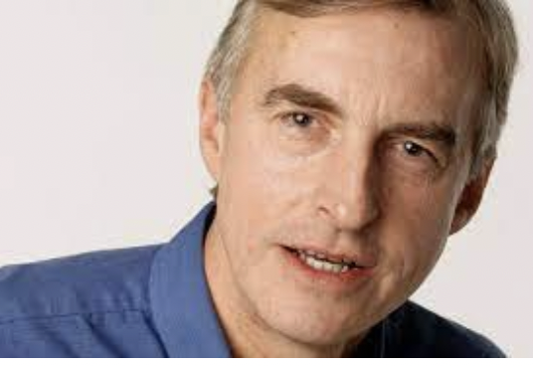
STEVE RADCLIFFE & FIONA MOORE

Steve Radcliffe is one of Europe’s top leadership Experts. In the last 20 years, he has provided leadership coaching to over 50 chief executives and heads of the Civil Service, the NHS and other government departments. He is most well-known for his powerful leadership development approach, Future – Engage – Deliver. (FED) The London Times describes FED as:

"The no-nonsense approach… shaking up the world of leadership"
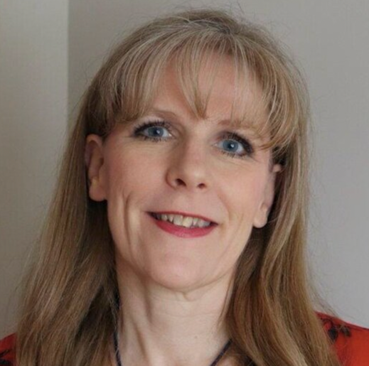
Fiona has worked with Steve Radcliffe for a number of years and is herself an award-winning Leadership and Development expert with over 25 years’ experience designing, leading and delivering coaching, leadership and talent management programmes, across a diverse range of sectors and organisations: manufacturing, financial services, retail, service, data management, banking, Education and Health. She is a qualified coach, facilitator and leader of teams. The Transform Applied bespoke programmes impact hugely on leadership awareness, engagement, staff performance and adding overall value to the system.

